Requirement Analysis — Data Flow Diagrams and User Stories
Implement Client Script & UI Policy (Incident)
01 October 2026 | Requirement Analysis | SWTID-2026-4755
Field | Project value
Date | 01 October 2026
Team ID | SWTID-2026-4755
Project Name | Implement Client Script & UI Policy (Incident)
Analysis focus | Model the Incident control flow and express requirements as testable stories
1. Data-flow overview
The data flow begins with the service desk agent entering or editing an Incident. The form or list event sends the current field context to the UI Policy or Client Script. The control evaluates the condition and either updates the UI, provides feedback, blocks the action, or allows a valid record change to reach the Incident table and native audit/history.
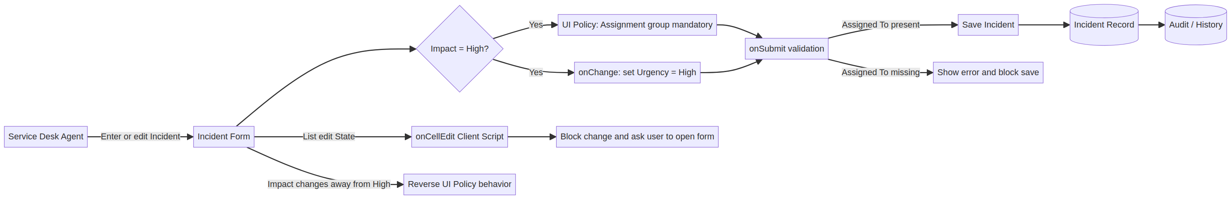
Generated deterministic data-flow diagram for the Incident UI Policy and Client Script solution.
2. Flow steps
Step | Actor / component | Input | Decision / output
1 | Service desk agent | Create/open Incident or edit list row. | Current form/list event identified.
2 | UI Policy | Impact value. | If Impact = 1, activate High Impact Control; otherwise reverse.
3 | onChange Client Script | Impact change. | Set Urgency = High and show info message when value = 1.
4 | onSubmit Client Script | Impact and Assigned To values. | Block save with field error if high impact and owner missing.
5 | onCellEdit Client Script | State list edit. | Alert user and callback(false); keep original State.
6 | Incident table | Validated form submission. | Persist valid fields and native history/reporting.
3. User stories
ID | User story | Acceptance criteria
US-01 | As a service desk agent, I want high-impact Incidents to require an Assignment group so that the record has a routing destination. | Assignment group is mandatory only when Impact is High.
US-02 | As a service desk agent, I want Urgency to align automatically with High Impact so that I do not enter conflicting triage values. | Changing Impact to High sets Urgency to High and shows a message.
US-03 | As an Incident manager, I want the system to prevent save when Assigned To is missing so that no high-impact record is ownerless. | Submit is blocked and the Assigned To error is visible.
US-04 | As an administrator, I want temporary controls to reverse so that lower-impact Incidents are not over-restricted. | Changing Impact away from High restores normal behavior.
US-05 | As an Incident manager, I want State list editing blocked so that workflow transitions use full form context. | Direct State list edit is rejected with an explanation.
US-06 | As a service desk agent, I want form-based State updates to remain available so that legitimate workflow progression is not blocked. | State change through the Incident form saves successfully.
US-07 | As an administrator, I want named and scoped scripts so that troubleshooting and maintenance are straightforward. | Each script has the correct table, type, field, and active state.
US-08 | As a reporting owner, I want validated values stored in the native Incident table so that operational reports remain trustworthy. | Valid records save and appear in history/reporting.
4. Use-case acceptance matrix
Use case | Precondition | Expected result
High-impact creation | New Incident; Impact changed to High. | Assignment group mandatory; Urgency High/read-only.
Invalid save | Impact High; Assigned To empty. | Error shown; no save.
Valid save | Impact High; group and owner populated. | Save succeeds.
Reverse condition | Existing high-impact Incident; Impact changed to Medium. | Temporary controls reverse.
Unsafe list edit | Incident list; State double-clicked. | Alert shown; State unchanged.
Safe form update | Incident form; State changed. | Update succeeds.

